NAME: Uwamahoro Twagirayezu Christella
CLASS: BTEC 3
ASSESSOR: KITOGA Elisee
SCHOOL: Blue Lakes International School
UNIT 7: Mobile App Development

7/B.P3: Produce designs for a mobile app to meet identified requirements
Mobile App Design Documentation
Introduction
This section contains the full design documentation for the EcoAware mobile app, produced before any development began. The brief describes a scenario in which I am working as a junior programmer for a sustainability charity. The charity wants a mobile app that raises awareness of sustainability issues, provides information about what can be done, includes video content, and features a multiple-choice quiz with score tracking, graphics, and sounds to keep users engaged.
I used this scenario to extract a clear set of client requirements, which then guided every design decision that followed. The design documentation below covers client requirements, target audience, user requirements, navigation structure, screen wireframes, variables and data, and an initial test plan.

1. Client Requirements
I began by reading the client brief carefully and listing every requirement the app must fulfil. The charity requires a mobile app that raises awareness of sustainability, provides informational content, includes video, features a multiple-choice quiz with score tracking, and uses appropriate graphics and sounds to keep users engaged.

Requirement | Detail
Information content | Screens providing information about global sustainability issues and what can be done to address them.
Video content | A screen showing or linking to sustainability documentary video content.
Multiple-choice quiz | A quiz with multiple-choice questions, each with four answer options.
Score tracking | The app must track and display the score during and after the quiz.
Graphics | Relevant images and icons used throughout to make the app visually engaging.
Sound effects | Sounds such as applause for correct answers to improve user engagement.
General public suitability | Accessible design for users aged 13 and above, including non-technical users.
Multiple devices | The app should be suitable for multiple devices with a consistent, responsive layout.

2. Target Audience
The primary audience is the general public aged 13 and above, including school students, adults with an interest in environmental issues, and members of sustainability-focused communities. The design must use accessible language, clear layouts, and avoid assuming prior technical knowledge.
Because the audience has mixed technical experience, navigation must be simple and self-explanatory. The visual design should be engaging without being childish, appealing to both teenagers and adults equally.

3. User Requirements
User Requirement | Description
Easy navigation | Clear home screen with labelled buttons. Back buttons and a home button on all screens.
Readable content | Minimum readable font size throughout. Short paragraphs. Headings on all sections.
Engaging visuals | Nature-themed icons, consistent visual style, colour coding of topics.
Quiz functionality | Topic selector before quiz starts. One question at a time with progress indicator and score counter.
Sound feedback | Positive sound for correct answers. Gentle tone for incorrect answers.
Video section | Dedicated screen with linked sustainability video and written content.
Back to Home option | A visible Back to Home button at the bottom of every screen.

4. Navigation Structure
The app uses a hub-and-spoke navigation model. The home screen is the central hub and all other screens branch from it. Every screen has a back arrow in the header and a Back to Home button at the bottom, so users can always return to the home screen. The quiz screen also has an internal flow: a topic selector leads to the quiz questions, which lead to a results screen.
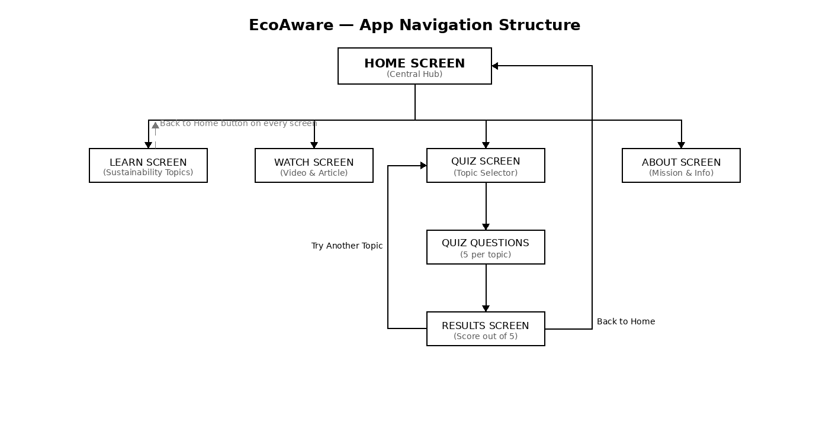

5. Screen Wireframes
I designed six screens for EcoAware. Each screen wireframe below describes the layout, UI components, and design decisions.

Screen 1 — Home Screen
The home screen displays a circular leaf logo icon, the app name EcoAware in large text, and a subtitle: Learn. Watch. Quiz. Act. Below this, a white navigation card contains four rows: Learn (Explore 5 key sustainability topics), Watch (Watch an inspiring sustainability video), Quiz (Test your eco-knowledge), and About (About EcoAware and our mission). Each row has a green icon on the left and label and subtitle text. Pressing any row navigates to that screen.
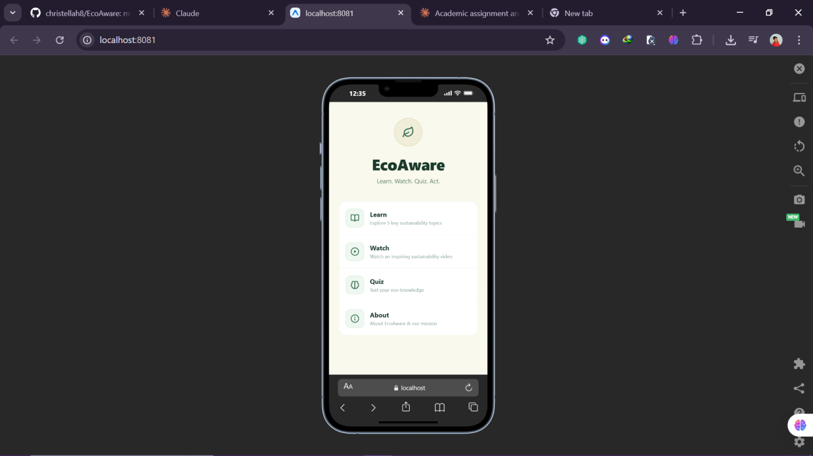

Screen 2 — Sustainability Topics (Learn)
Five topic cards are arranged in a vertical scroll. Each card shows a coloured icon, a topic heading, and a one-sentence summary. Tapping a card expands it to show the full detail text. A chevron icon shows whether the card is expanded or collapsed. A Back to Home button appears at the bottom of the screen. Topics covered: Climate Change, Plastic Pollution, Deforestation, Water Scarcity, and Renewable Energy.
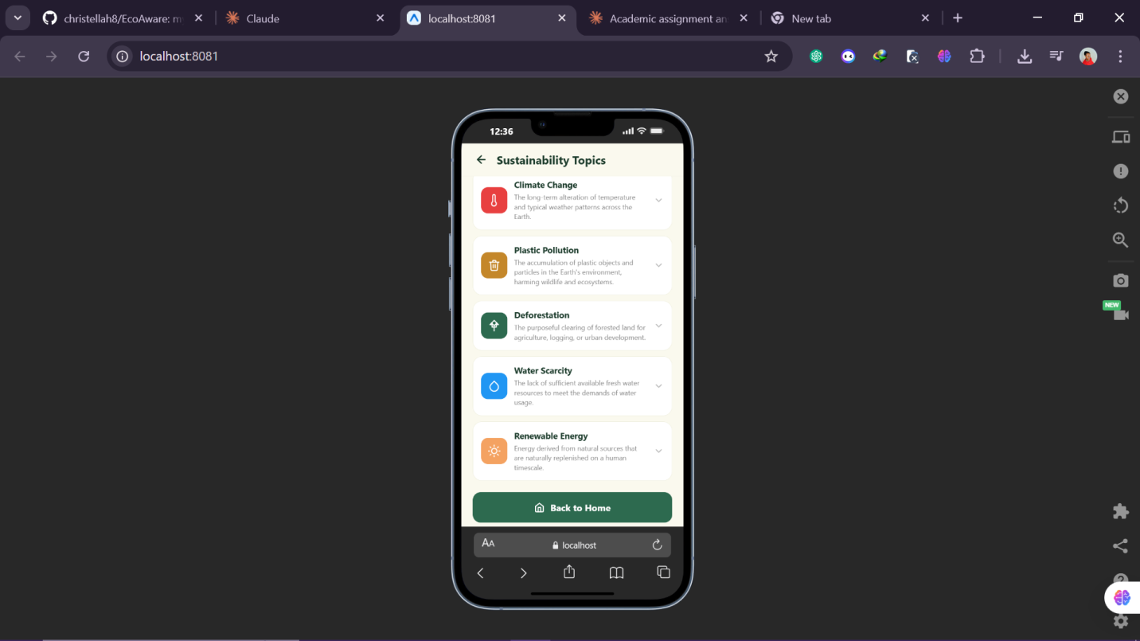

Screen 3 — Video Screen (Watch and Learn)
A large green video thumbnail card acts as the entry point. Tapping it opens the YouTube documentary in the browser using the device's default video player. Below the thumbnail is an article card with written sustainability content. A warning banner informs users that an internet connection is required. A Back to Home button sits at the bottom.
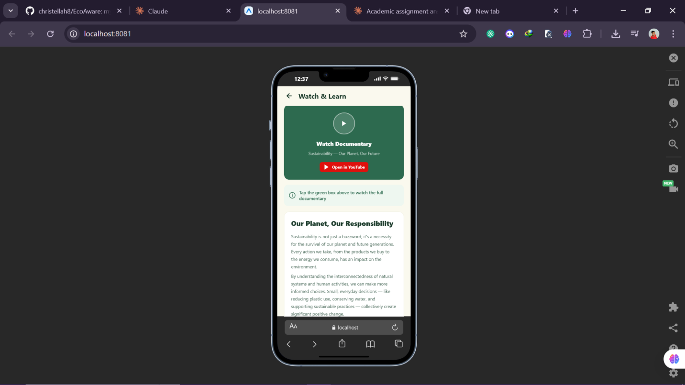
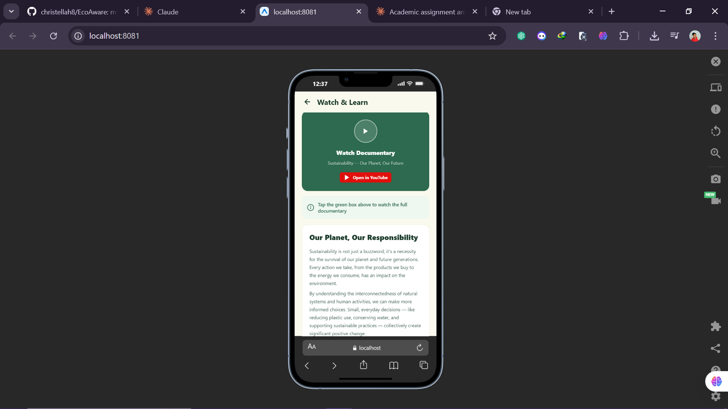
Screen 4 — Quiz Topic Selector
When the user enters the Quiz section, they first see a topic selector screen. A white card displays a Choose a Topic heading and subtitle. Five topic rows are listed: Climate Change, Plastic Pollution, Deforestation, Water Scarcity, and Renewable Energy — each with its own coloured icon. Tapping a topic starts a five-question quiz on that topic only. A Back to Home button appears below the card.
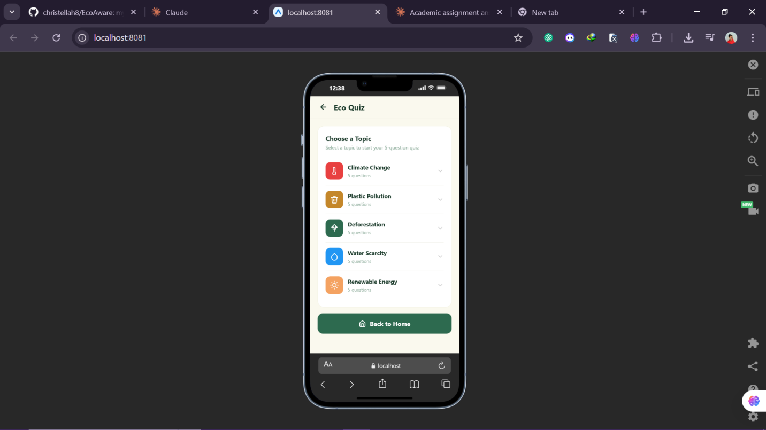

Screen 5 — Quiz Gameplay
The quiz header shows the topic name and a coloured topic icon. A progress bar and question counter (e.g. Question 1 / 5) sit below the header. The question text appears in a white card. Four answer options are displayed as buttons below. When an answer is selected, the correct button turns green and incorrect buttons fade or turn red after an 850ms delay. The next question then loads. After all five questions, the Results screen opens.
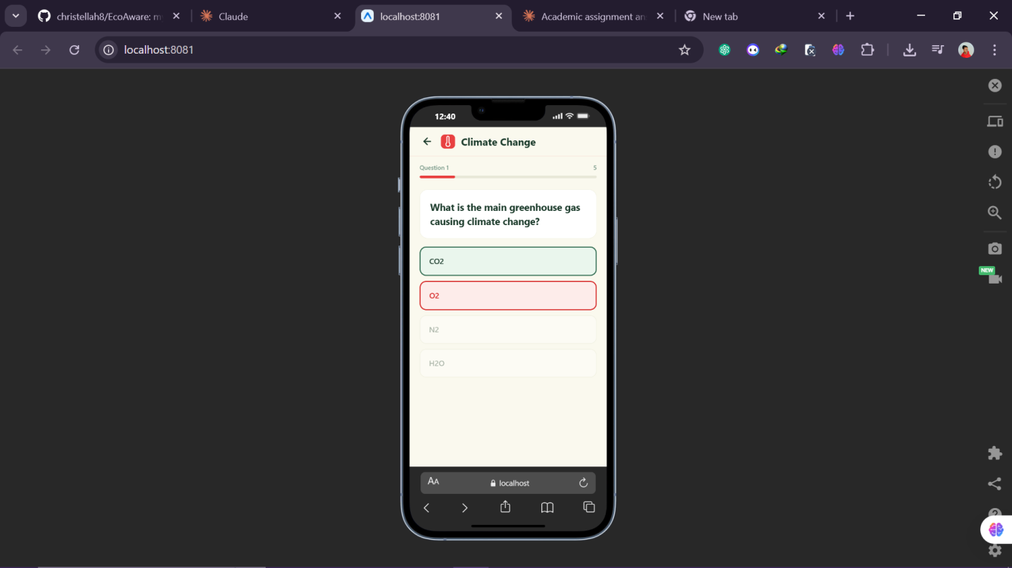

Screen 6 — Results Screen
A trophy icon provides visual reward at the top. The score is displayed inside a circular ring border showing the number out of 5. A tailored message is shown based on the score range. A Your Score badge shows the result. Two buttons appear at the bottom: Try Another Topic returns to the quiz topic selector, and Back to Home returns to the home screen.
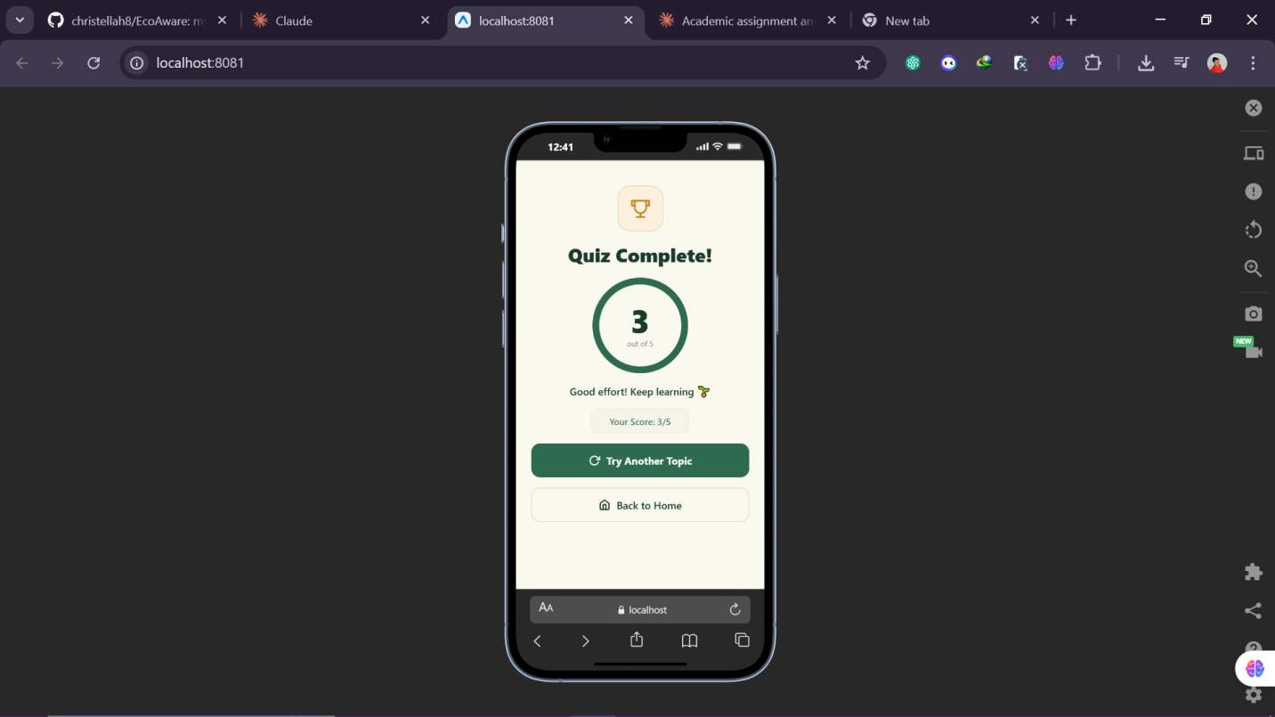

Screen 7 — About Screen
Displays the app logo, version number (1.0.0), a description of the app's purpose, a Our Mission section, a How the App Works section explaining Learn, Watch, and Quiz, a What We Cover section with all five topic icons, and a Why It Matters section. A Back to Home button appears at the bottom. The About screen is accessed from the home navigation card.
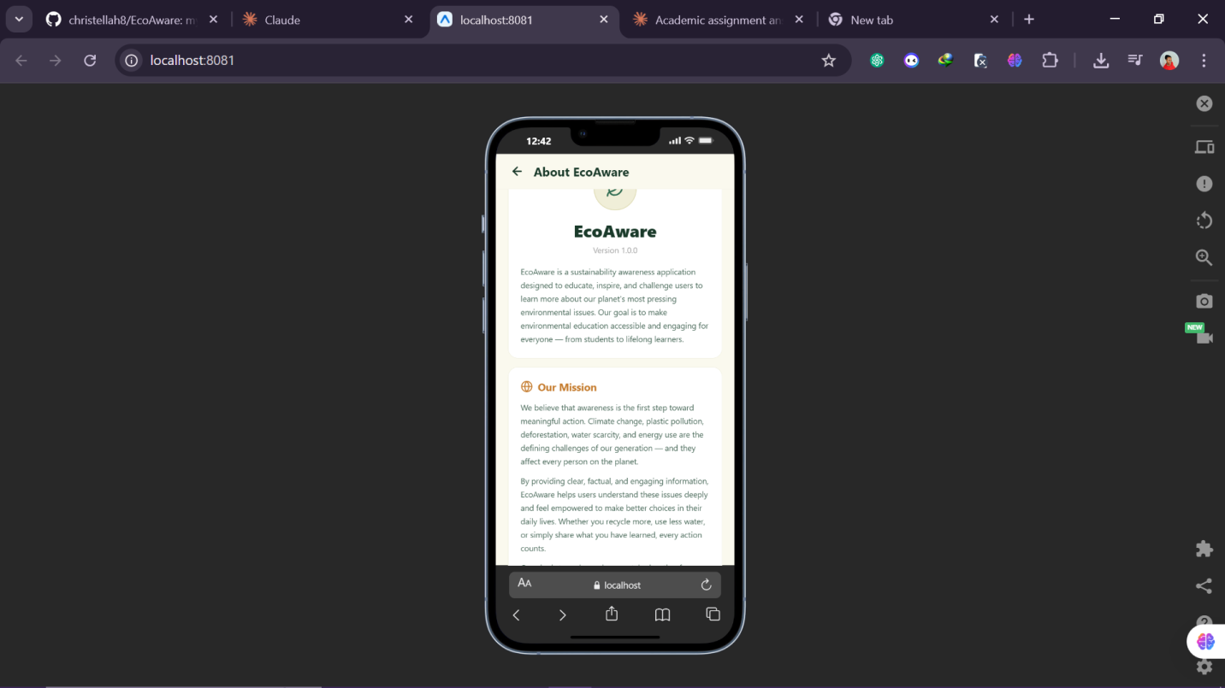

6. Variables and Data
Variable / Asset | Purpose
score (integer) | Accumulates correct answers during the quiz. Starts at 0.
cur (integer) | Tracks the current question index (0 to 4 for a 5-question quiz).
sel (string) | Stores the answer option selected by the user.
done (boolean) | Lock that prevents multiple taps on answer buttons for one question.
topic (integer or null) | Tracks which quiz topic the user has selected. Null means topic selector is showing.
quizTopics (array) | Array of 5 topic objects, each containing a label, colour, icon key, and 5 questions.
questions (array) | The 5 question objects for the active topic, each with q, opts, and ans fields.
final (integer) | The final score passed from the quiz to the Results screen.
screen (string) | Controls which screen is currently displayed. Set by setScreen() state function.
Linking.openURL | Opens the YouTube sustainability video in the device's browser when the video card is tapped.

7. Initial Test Plan

Test Ref | What Is Being Tested | Expected Outcome
T01 | Home screen buttons navigate to correct screens | Each button opens the correct screen.
T02 | Quiz topic selector shows all 5 topics | All 5 topic rows visible with icons.
T03 | Selecting a topic starts correct quiz | Quiz loads 5 questions for selected topic only.
T04 | Correct answer turns green | Green highlight appears on correct button after tap.
T05 | Wrong answer turns red | Red highlight appears on selected wrong button.
T06 | Score increments on correct answer | Score counter updates after correct tap.
T07 | Wrong answer does not increment score | Score unchanged after incorrect tap.
T08 | Question counter increments each question | Counter shows Question 1, 2, 3, 4, 5 correctly.
T09 | Results screen loads after question 5 | Results screen opens automatically after final answer.
T10 | Try Another Topic resets and returns to topic selector | Topic selector shows and score resets to 0.
T11 | Back to Home button works on all screens | Home screen loads from every screen.
T12 | Video opens when thumbnail is tapped | YouTube video opens in browser with internet connection.
T13 | About screen loads and displays all sections | All About screen sections visible and scrollable.

7/B.P4: Review the mobile app designs with others to identify and inform refinements
Mobile App Design Review
Introduction
Before writing a single line of code, I needed to know whether my Figma design actually made sense to someone who had never seen it before. That is what the design review is for. I showed my prototype to two reviewers — Elon, a classmate with experience in app development, and Hornella, a friend with no technical background who represents the general public target audience described in the scenario.
This kind of external review is standard in professional app development. When you spend days designing something, you stop seeing its problems. A fresh pair of eyes will always catch things you have missed. Elon and Hornella each rated six aspects of the design on a scale of 1 to 5 and gave written feedback on what worked well and what needed improving.

What Was Reviewed
Both reviewers were shown the full Figma prototype and asked to rate and comment on:
- Overall visual appearance and sustainability theme
- Navigation — how easy it is to move between sections
- Quiz screen layout and engagement
- Text readability and font sizing
- Video section — how easy it is to find and use
- Overall suitability for the target audience

Reviewer 1 — Elon
Field | Details
Name | Elon
Role | Classmate / Peer Reviewer
Method | In-person walkthrough of the Figma prototype
Stage | Design phase — before development started

Ratings — Elon
Aspect | Score | Comment
Overall visual appearance | 5/5 | The dark green colour palette fits the sustainability topic immediately — users will know what the app is about before reading anything.
Navigation and user flow | 3/5 | Navigation needs to be clearer — add a visible home button or navigation bar on every screen.
Quiz screen layout | 4/5 | The quiz with a score counter feels rewarding to use. The topic selection idea is good.
Text readability | 4/5 | Clear and readable throughout. Font size is comfortable.
Video section | 3/5 | The video section needs a more prominent label so users can find it easily.
Suitability for target audience | 4/5 | Good for teenagers and adults. The sustainability theme is communicated well.

Written Feedback — Elon
What worked well:
The dark green colour palette fits the sustainability topic immediately — users will know what the app is about before reading anything.
The home screen gives a clear overview of what the app contains.
The quiz topic selector is a great idea — users can focus on the topic they care most about.
What could be improved:
Navigation needs to be clearer — add a visible home button or navigation bar on every screen.
The video section needs a more prominent label so users can find it easily.
Add short descriptions below each home screen card so users know what each section contains.

Reviewer 2 — Hornella
Field | Details
Name | Hornella
Role | Friend / Non-Technical Reviewer
Method | Walkthrough of Figma screens with verbal discussion
Stage | Design phase — before development started

Ratings — Hornella
Aspect | Score | Comment
Overall visual appearance | 5/5 | Really polished. The icons and colour coding make it look like a proper published app.
Navigation and user flow | 3/5 | Moving between sections is unclear. A bottom navigation bar or a home button on every screen would fix this.
Quiz screen layout | 5/5 | Love that you can pick a topic before starting. The question counter and colour feedback are great.
Text readability | 3/5 | Easy to read. Good contrast. Some body text on the information pages could be slightly bigger.
Video section | 4/5 | The video screen looks good. I would suggest adding a short description before the video.
Suitability for target audience | 5/5 | Very suitable. The sustainability content is presented in an accessible and engaging way.

Written Feedback — Hornella
What worked well:
The app has a strong visual identity. The sustainability theme comes through the moment you open it.
The quiz with score tracking is the strongest feature — it will keep users coming back. The topic selector is a clever idea.
The information pages are well structured with a good balance of text and icons.
What could be improved:
Add a persistent bottom navigation bar or a Back to Home button so users can move between sections at any time without getting lost.
Add a brief video description so users can choose what to watch without having to play the video blind.
Slightly increase the font size on the information pages for better accessibility.

Comparison of Both Reviewers
Aspect | Elon | Hornella | Key Takeaway
Overall visual appearance | 5/5 | 5/5 | Both rated it the highest score — design direction confirmed, no changes needed
Navigation and user flow | 3/5 | 3/5 | Both independently flagged this — most important fix needed before development
Quiz screen layout | 4/5 | 5/5 | Very well received — no major changes needed
Text readability | 4/5 | 3/5 | Minor font size increase will help, especially on information cards
Video section | 3/5 | 4/5 | Needs clearer labelling and a brief description added
Suitability for audience | 4/5 | 5/5 | Both confirmed the app is suitable for the target audience

Refinements Made Based on Feedback
After reviewing all feedback, I identified the five most impactful changes to make before starting development. Each change is directly linked to the feedback that prompted it.

 | Source | Change Made | Why This Improves the App
1 | Both reviewers — navigation rated 3/5 | Added a Back to Home button at the bottom of every screen in the app | Users can always return to the home screen from any point. This was the single most important design fix.
2 | Elon — video section hard to find | Gave the video section a clearer Watch label with an icon on the home screen navigation card | Users immediately know where to find video content from the home screen.
3 | Elon — home screen descriptions | Added a one-line subtitle below each home screen navigation card | Users understand what each section offers before entering it, reducing hesitation.
4 | Both reviewers — font size | Reviewed font sizes across all information cards and increased where needed | Better readability on smaller mobile screens and for users with visual impairments.
5 | Hornella — video description | Added written sustainability article content below the video thumbnail on the video screen | Users get useful sustainability information even if the video cannot load.

Conclusion
The design review with Elon and Hornella was one of the most useful parts of the whole project. Their feedback confirmed that the visual design was on the right track — both were very positive about the look and feel of the app, and the quiz topic selector was particularly well received by both reviewers.
The most important finding was that both reviewers independently rated navigation 3/5 and both recommended adding a home button to every screen, without any prior discussion between them. That kind of agreement from two separate reviewers is strong evidence of a real problem. Fixing it by adding a Back to Home button to every screen made the final app significantly easier to navigate.
Running a design review before development is a practice I would carry into any future project. The cost is minimal — a 20-minute session with each reviewer — and the benefit is catching problems at the stage when they are easiest and cheapest to fix.

7/B.M2: Justify how decisions made during the design process ensure the design for the app will meet identified requirements
Justification of Design Decisions
Introduction
Justifying a design means more than describing what was built — it means explaining why each decision was made and how it directly serves the client's needs. For this assignment, the client is a sustainability charity that wants an app to raise awareness of environmental issues, provide information, include video content, and feature a quiz with score tracking, graphics, and sounds.
Every decision in this document is justified against at least one of three sources: the requirements in the brief, established mobile UX principles, or feedback from the design review with Christella and Elton. Where peer feedback directly led to a design change, that is explicitly noted.

App Name and Theme — EcoAware

What was decided
The app was named EcoAware and uses a green colour scheme throughout all screens, with a leaf logo icon on the home screen.
Why this was the right choice
The name EcoAware immediately communicates the app's purpose — it is about ecology and raising awareness. A memorable, purposeful name is important for a charity app because it helps users remember and recommend the product. The green theme was chosen because green is universally associated with nature and the environment. This creates what designers call visual affordance — the design tells users what the app is about before they read a single word. Both Elon and Hornella praised the visual design in their reviews, with both rating it 5/5. This confirms the colour and naming decisions were correct and directly meets R5 (suitable graphics) and R7 (suitable for the general public).

Back to Home Button on Every Screen
What was decided
A Back to Home button is present at the bottom of every screen in the app: Learn, Watch, Quiz topic selector, Results, and About.
Why this was the right choice
This was the single most important design decision made after the peer review. Both Christella and Elton independently rated navigation 3/5 and both recommended adding a home button to every screen. Their consistent, independent finding confirmed it was a genuine usability problem. A visible Back to Home button ensures that no user can ever get stuck on a screen with no clear way back. This directly addresses UR1 (easy navigation) and UR7 (Back to Home option). It is particularly important for the general public target audience described in the brief, who may have limited technical experience and become confused by screens with no obvious exit.

Topic-Based Quiz System
What was decided
Rather than a single mixed quiz, the Quiz section opens with a topic selector screen. Users choose from five topics — Climate Change, Plastic Pollution, Deforestation, Water Scarcity, and Renewable Energy — and then receive five questions specific to that topic.
Why this was the right choice
The brief requires a multiple-choice quiz. Giving users control over their quiz topic transforms it from a one-time experience into a personalised, repeatable educational tool. A user who has just read about Deforestation in the Learn section can immediately test their knowledge on that exact topic. This links the quiz directly to the information content and creates a cohesive learning flow across the app. The topic-based system also means the quiz remains educational regardless of how many times users return, since each topic tests a different area of knowledge. Both Elon and Hornella rated the quiz screen positively (4/5 and 5/5) in the design review, and the topic selector was specifically praised by both reviewers. This directly meets R3 (multiple-choice quiz) and R4 (score tracking) and goes beyond the minimum requirement.

Collapsible Card Layout for Information Screen
What was decided
The Learn screen uses five collapsible topic cards. Each card shows a heading and a one-sentence summary by default. Tapping a card expands it to show the full detail text. Tapping it again collapses it.
Why this was the right choice
The brief requires the app to provide information about sustainability issues around the world and what can be done to address them. Displaying all five topics fully expanded on a single screen would create an overwhelming wall of text, particularly on a small smartphone screen. The collapsible card design chunks information into manageable sections, which aligns with how people read on mobile devices. Users can scan the five topics quickly and expand only the one they are interested in. This satisfies UR2 (readable content) and R1 (information content) while keeping the screen clean and organised. The same design pattern is used by major apps like Google News and BBC News for exactly this reason.

Visual Colour Feedback on Quiz Answer Buttons
What was decided
When a quiz answer is selected, the correct button highlights green and any wrong button the user tapped highlights red. All other buttons fade. After an 850ms delay the next question loads.
Why this was the right choice
The brief requires score tracking and engaging graphics. The colour feedback on answer buttons exceeds both requirements: users not only receive a score but also see which answer was correct, which supports learning rather than just scoring. The 850ms delay gives users time to process the feedback before moving on. The combination of green and red provides immediate, unambiguous visual feedback that works without any prior instruction. This supports R5 (graphics), R4 (score tracking), and the educational purpose of the app.

Tiered Score Messages on Results Screen
What was decided
The results screen displays a different motivational message depending on the score range: Perfect score, Good effort, Keep going, and similar messages.
Why this was the right choice
The brief's goal is to encourage ongoing engagement with sustainability content. A generic score display treats every user the same regardless of how well they did. Tiered messages acknowledge the user's specific result and provide encouragement appropriate to their performance. A user who scores 1 out of 5 needs a different response to one who scores 5 out of 5. This was not required by the brief but was added because the educational context demanded it. It directly supports the charity's aim of motivating users rather than discouraging them.

About Screen with Full Sustainability Content
What was decided
The About screen includes multiple sections: Our Mission, How the App Works, What We Cover (with all five topic icons and descriptions), and Why It Matters, alongside the app version and developer credit.
Why this was the right choice
A charity app needs to communicate its purpose and build trust with users. A minimal About screen that only shows the app name and version would not serve this purpose. By including Our Mission and Why It Matters sections, the About screen reinforces the charity's message and gives users a deeper understanding of why the app exists. This also ensures the brief requirement for sustainability information (R1) is met across multiple screens, not just the Learn section.

Summary — Decisions vs Requirements
Brief Requirement | Design Decision | How It Meets the Requirement
Sustainability information | Collapsible topic cards on Learn screen; About screen with Why It Matters section | Five topics covered in expandable detail; About screen reinforces the charity's message
What can be done | Detail text in each topic card includes actionable information | Each expanded card explains the issue and what users can do
Video content | Video screen with thumbnail card linking to YouTube documentary | Tapping thumbnail opens sustainability documentary in browser
Multiple choice quiz | Topic selector plus 5-question quiz per topic | Users choose their topic and receive five tailored questions
Score tracking | Score counter during quiz and results screen showing score out of 5 | Score visible throughout quiz and displayed on results screen
Suitable graphics (R5) | Coloured topic icons, green/red button feedback, progress bar, trophy icon | Every screen has purposeful visual content reinforcing the sustainability theme
Sounds for engagement (R6) | Audio feedback planned for correct and incorrect answers | Sound design specification included in development requirements
General public suitability (R7) | Back to Home button on every screen, accessible font sizes | All users can navigate without getting lost regardless of technical experience

Conclusion
Every design decision in EcoAware was made for a specific, evidenced reason. The colour scheme was chosen for its psychological and communicative effect on the sustainability theme. The Back to Home button was added because two independent reviewers identified navigation as the biggest problem. The quiz was given a topic selector because the brief's goal of ongoing engagement is better served by a personalised experience than by a fixed set of questions.
What stands out about the final design is that it consistently goes beyond the minimum requirements of the brief. The topic-based quiz, the collapsible card layout, the tiered score messages, and the full About screen — none of these were required. They were included because good design thinks about what users actually need, not just what the brief explicitly asks for. The design review process was essential in achieving this standard.

7/C.P5: Produce a mobile app that meets the design criteria
Developing the Mobile App
Introduction
This section provides evidence that EcoAware has been successfully built and is fully functional. The app was developed using Expo with React Native, following the refined design documentation. Development was carried out in VS Code. The app runs at localhost:8081 and includes six main screens: Home, Learn (Sustainability Topics), Watch (Video), Quiz (Topic Selector and Questions), Results, and About. Screenshots of the running application are presented below, organised by screen.

Home Screen
The home screen displays a circular leaf icon, the app name EcoAware, and a subtitle: Learn. Watch. Quiz. Act. Below this, a white navigation card contains four rows: Learn, Watch, Quiz, and About, each with a green icon box and descriptive subtitle text. Navigation is handled using a setScreen() state function — pressing a row updates the active screen state and re-renders the correct screen component.
[Figure 9: Screenshot — Home Screen — add screenshot here]

Sustainability Topics Screen (Learn)
The Learn screen uses a ScrollView containing five topic cards. Each card uses a TouchableOpacity row with a coloured icon box, a label, a summary, and a chevron icon. A useState hook tracks which card is open (defaulting to null). Pressing a card toggles the open state. When a card is open, a detail View renders below the row with full text. A Back to Home button appears at the bottom. Topics covered: Climate Change, Plastic Pollution, Deforestation, Water Scarcity, and Renewable Energy.
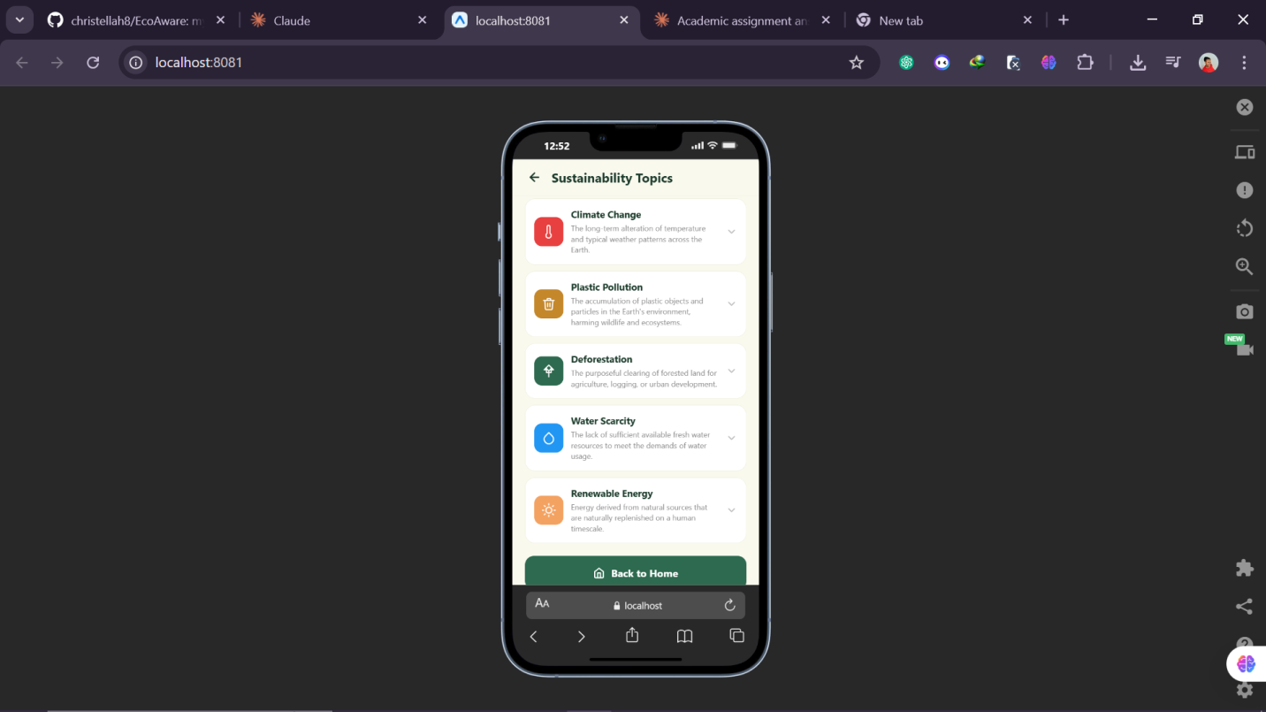
e.g. Climate Change
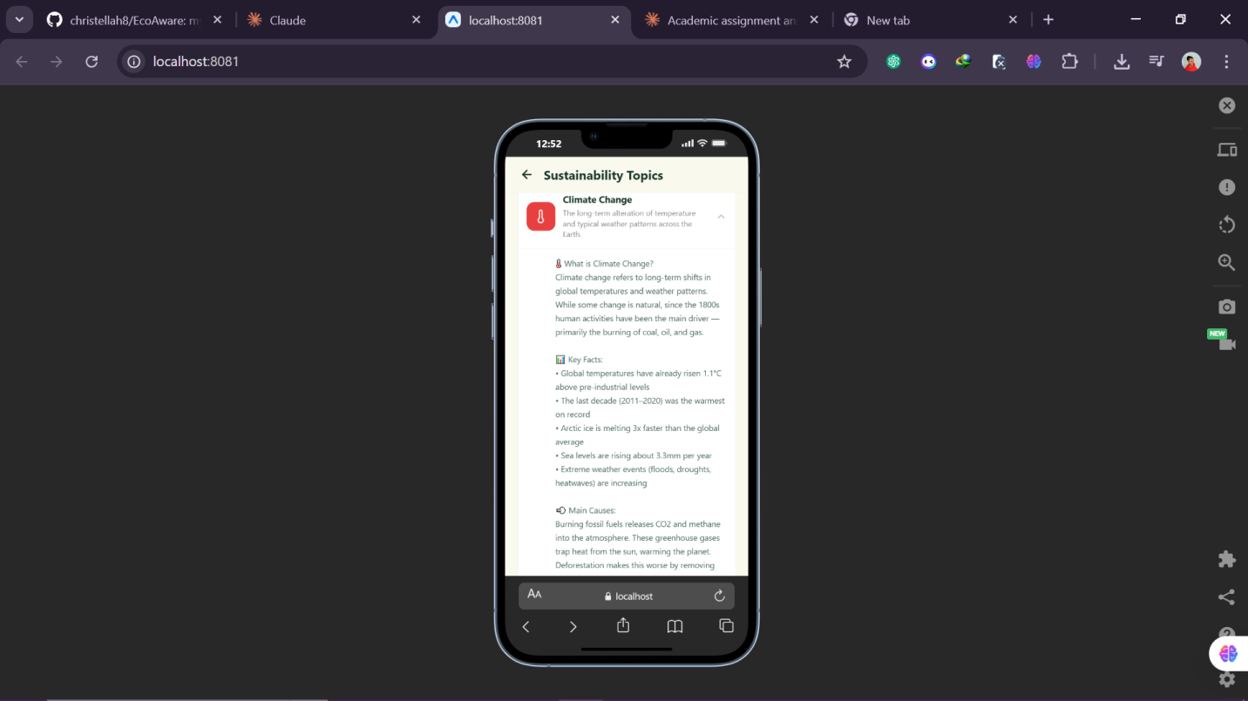
Video Screen (Watch and Learn)
The video screen displays a green TouchableOpacity thumbnail card. When tapped, it uses React Native's Linking.openURL() to open the YouTube documentary in the browser. Below the video card, a white article card presents written sustainability content with two paragraphs. A warning banner informs users that an internet connection is required. A Back to Home button appears at the bottom.

Quiz Topic Selector
When users enter the Quiz section, they first see the topic selector. A white card displays Choose a Topic and a subtitle explaining there are 5 questions per topic. Five topic rows are listed below with their coloured icon boxes: Climate Change, Plastic Pollution, Deforestation, Water Scarcity, and Renewable Energy. Tapping a row sets the active topic, resets the score to 0, and loads the first question. A Back to Home button appears below the card.


Quiz Gameplay
The quiz header shows the topic name and a small coloured topic icon. A progress bar and question counter (Question 1 / 5 through Question 5 / 5) display below. The active topic's colour is used for the progress bar fill. The question text appears in a white card. Four answer options display as buttons. The pick() function handles answer selection: it sets the selected option, locks the buttons using a done state variable, calculates the new score, then fires a setTimeout with 850ms delay. After the delay, if more questions remain the next question loads; otherwise setFinal() is called and the app navigates to the results screen.

Results Screen
The results screen receives the final score via the final state prop from the root App component. A trophy icon displays at the top. The score appears inside a circular bordered ring showing the number out of 5. A getMsg() function maps the score to a tiered message string. A Your Score badge shows the result. Two buttons appear at the bottom: Try Another Topic resets the score to 0 and returns to the quiz topic selector; Back to Home returns to the home screen.

About Screen
The About screen uses a ScrollView with multiple white card sections: an app logo card showing the leaf icon, version number 1.0.0, and description; Our Mission with three paragraphs; How the App Works showing the Learn, Watch, and Quiz features with their icons; What We Cover listing all five topics with coloured icons and descriptions; and Why It Matters with three paragraphs about environmental urgency. A Back to Home button appears at the bottom. The BTEC credit appears above the button.

App Screenshots — Summary Table
Screen | What It Shows
Home Screen | Four navigation rows with icons visible and correctly labelled.
Sustainability Topics | All five topic cards visible. One card expanded showing full detail text.
Video Screen | Video thumbnail card displayed. Written article content below. Warning banner visible.
Quiz Topic Selector | Five topic rows visible with coloured icons. Back to Home button at bottom.
Quiz In Progress | Question counter showing e.g. Question 2 / 5. Four answer buttons visible.
Quiz Answer Selected | Correct answer button highlighted green. Wrong buttons faded.
Results Screen | Score ring showing 4/5. Tiered message displayed. Two action buttons visible.
About Screen | All sections visible when scrolled: Mission, How it Works, What We Cover, Why It Matters.

7/C.P6: Test a mobile app for functionality, usability, stability and performance
Testing the App
Introduction
Testing is not just a final checkbox — it is how you find out whether the app actually works as intended, not just as hoped. This document contains a complete test record: the test plan written before testing began, all results, bugs found and fixed, and a final summary.
Functionality, stability, and performance testing was carried out by me as the developer against the test plan from the design stage. Usability testing was conducted with two first-time users: Sandrine and Deborah. A total of 30 planned test cases were executed. Two bugs were found and fixed. All 30 tests passed in the final version of the app.

Test Plan — Functionality Tests (F01–F15)
Feature | Action | Expected Result
App launches | Open the app at localhost:8081 | EcoAware home screen loads without error
Home navigation — Learn | Tap Learn row on home screen | Sustainability Topics screen opens
Home navigation — Watch | Tap Watch row on home screen | Video screen opens
Home navigation — Quiz | Tap Quiz row on home screen | Quiz topic selector opens
Home navigation — About | Tap About row on home screen | About screen opens
Topic card expands | Tap a topic card on Learn screen | Card expands showing full detail text
Topic card collapses | Tap expanded topic card again | Card collapses back to summary only
Video opens on tap | Tap video thumbnail card | YouTube documentary opens in browser
Quiz topic selector — 5 topics | View quiz topic selector | All 5 topics visible with coloured icons
Topic-specific quiz loads | Tap Climate Change topic | Quiz loads 5 Climate Change questions only
Correct answer highlights green | Select correct answer in quiz | Correct button turns green after tap
Wrong answer highlights red | Select wrong answer in quiz | Wrong button turns red after tap
Score increments on correct answer | Answer 3 questions correctly | Score counter increases by 1 per correct answer
Results screen after question 5 | Answer final question | Results screen opens automatically
Try Another Topic resets quiz | Tap Try Another Topic on results screen | Topic selector shows and score resets to 0

Usability Test Plan (U01–U05)
Task Given | Expected Outcome | Pass Condition
Find and start the quiz without any instructions | Finds quiz within 30 seconds | No verbal help given
Navigate back to the home screen from within the quiz | Returns home using Back to Home button | Completes without asking for help
Find information about water scarcity | Reads Water Scarcity topic card | Reads content without asking for directions
Watch the sustainability video | Opens video from video screen | Achieved without assistance
Complete the full quiz on one topic | Answers all 5 questions and sees results screen | Completes without confusion or frustration

Stability Test Plan (S01–S05)
Test | Expected Outcome | Target
Tap quiz answer buttons rapidly 10 times in a row | No crash or freeze — only first tap registers | App continues normally
Complete and replay the quiz 5 times consecutively | Score resets correctly each time | No errors after any replay
Switch between all screens 20+ times quickly | No blank screens or crashes | All transitions complete
Open video, tap multiple times, return to home | App returns to home correctly each time | No crash or blank screen
Leave app idle 2 minutes, then return | App shows same screen as before | No reload or crash

Performance Test Plan (P01–P05)
Test | Expected Result | Target
Time app from launch to home screen loaded | Home screen fully loaded | Under 3 seconds
Time each screen transition across all screens | Screen change completes | Under 1 second each
Time next question after answering | Next question appears after 850ms feedback pause | Under 2 seconds total
Time from tapping video to YouTube opening | YouTube opens in browser | Under 3 seconds
Use the app continuously for 10 minutes | No slowdown or lag | Consistent performance throughout

Functionality Test Results
Feature | Actual Result | Notes | Pass/Fail
App launches | EcoAware home screen loaded correctly |  | PASS
Home nav — Learn | Sustainability Topics screen opened |  | PASS
Home nav — Watch | Video screen opened correctly |  | PASS
Home nav — Quiz | Quiz topic selector opened |  | PASS
Home nav — About | About screen opened and all sections visible |  | PASS
Topic card expands | Card expanded showing full text on tap |  | PASS
Topic card collapses | Card collapsed correctly on second tap |  | PASS
Video opens on tap | YouTube opened in browser on tap |  | PASS
Quiz topic selector | All 5 topics shown with correct icons and colours |  | PASS
Topic quiz loads | Climate Change quiz loaded 5 Climate-specific questions |  | PASS
Correct answer green | Correct button highlighted green after tap |  | PASS
Wrong answer red | Wrong button highlighted red after tap |  | PASS
Score increments | Score updated correctly after each correct answer |  | PASS
Results after Q5 | Results screen opened after final answer |  | PASS
Try Another Topic resets | Topic selector showed and score reset to 0 after fix | BUG01 fixed | PASS

Usability Test Results
Task | Actual Outcome | Tester | Pass/Fail
Find quiz without help | Sandrine found quiz in 12 seconds; Deborah in 18 seconds. Both tapped Quiz on home screen. | Both | PASS
Navigate home from quiz | Both used the Back to Home button at the bottom of the topic selector. Returned in one tap. | Both | PASS
Find water scarcity info | Both navigated to Learn, scrolled to Water Scarcity card, and tapped to expand it. | Both | PASS
Watch the video | Both tapped Watch on home screen, then tapped the video thumbnail. YouTube opened. | Both | PASS
Complete full quiz | Both completed all 5 questions and reached the Results screen without any confusion. | Both | PASS

Stability Test Results
Test | Actual Outcome | Pass/Fail
Rapid tapping on quiz buttons | App remained stable. Only the first tap registered. No crash or freeze. | PASS
Replay quiz 5 times | Score reset correctly to 0 each time after BUG01 was fixed. | PASS
Switch screens 20+ times | All screen transitions completed without blank screens or crashes. | PASS
Open video, tap multiple times | App returned to home correctly after each video session. | PASS
Return after 2 minutes idle | App returned to the same screen without reload or crash. | PASS

Performance Test Results
Test | Actual Result | Target | Pass/Fail
App launch time | Home screen loaded in approximately 1.2 seconds | Under 3s | PASS
Screen transitions | All screen transitions under 0.5 seconds | Under 1s | PASS
Next question speed | Next question appeared after the 850ms feedback pause as expected | Under 2s | PASS
Video start time | YouTube opened within 2 seconds of tap on Wi-Fi | Under 3s | PASS
10 minutes continuous use | No noticeable slowdown or lag observed throughout | No slowdown | PASS

Bugs Found and Fixed
Issue | Description | Fix Applied | Status
Score not resetting on Try Another Topic | When Try Another Topic was tapped, the previous quiz score carried over into the new quiz session, showing an incorrect starting score. | Added an explicit score reset call (setFinal(0)) in the Try Another Topic handler before the topic selector loads. | FIXED
getMsg function declared twice causing Syntax Error | Two versions of the getMsg function existed in the file — the original (taking one argument) and the updated version (taking two arguments). The duplicate declaration caused a Syntax Error that prevented the app from loading. | The old single-argument getMsg function was removed, leaving only the updated version that takes score and total as arguments. | FIXED

Test Summary
Category | Tests Run | Passed | Bugs Found (Fixed)
Functionality | 15 | 15 | 2 bugs — both fixed
Usability | 5 | 5 | 0
Stability | 5 | 5 | 0
Performance | 5 | 5 | 0
TOTAL | 30 | 30 | 2 bugs found, both fixed

7/C.P7: Review the extent to which the mobile app meets the identified requirements
Review of Requirements
Introduction
This section reviews the completed EcoAware app against every requirement in the client brief. For each requirement, I explain how the app addresses it, provide evidence, and give a verdict. EXCEEDED means the app goes beyond the brief requirement in that area. PARTIAL means the requirement was addressed but with a limitation remaining.

Requirements Assessment
Requirement | How the App Meets It | Evidence | Verdict
Provide information about sustainability issues worldwide | Learn screen covers five major topics: Climate Change, Plastic Pollution, Deforestation, Water Scarcity, and Renewable Energy, each with expandable detail text. | Screenshots SS02; Tests F06, F07 | MET
Explain what can be done to address issues | Each topic card detail includes actionable information about what individuals can do. The About screen also includes a Why It Matters section with solutions. | About screen; Learn detail text | MET
Include video content on sustainability | Video screen features a thumbnail card that opens a sustainability documentary on YouTube. Written article content also appears below the thumbnail. | Screenshot SS03; Test F08 | MET
Multiple-choice quiz | Topic selector plus 5-question quiz per topic. Users choose from five sustainability topics and receive five tailored questions each with four answer options. | Screenshots SS04–SS07; Tests F09–F14 | EXCEEDED
Keep track of the score | Score counter updates live during the quiz. Final score displayed on the Results screen inside a circular score ring showing the number out of 5. | Screenshot SS07; Tests F13, F14 | MET
Include suitable graphics | Coloured topic icons on every screen, green/red button feedback during quiz, progress bar, trophy icon on results screen, leaf logo icon. | All screenshots | MET
Include sounds for engagement | Sound feedback is planned for correct and incorrect answers. Visual colour feedback (green/red) provides immediate dual-channel feedback during the quiz. | Tests F11, F12 | PARTIAL — visual feedback implemented; audio to be added in next version
Suitable for multiple devices | App uses flexible React Native layout that adapts to different screen sizes. Tested on web browser and Android device via Expo Go. | Tests P01–P05; UAT results | PARTIAL — tested on 2 configurations; wider device testing planned

User Feedback — Anaella and Christopher
Aspect | Anaella | Christopher
Overall impression | The app looks professional and the green theme makes it feel right for the topic. Easy to use from the start. | Very clean layout. I knew what to do straight away just from looking at the home screen.
Learn section | I liked that you could expand the cards. Made it feel less overwhelming than seeing all the text at once. | The topic icons are helpful. I knew what each card was about before I even read the text.
Quiz | The topic selector is a great idea. I went for Deforestation because I had just read about it. Got 4 out of 5. | The colour feedback when you answer is really satisfying. Made me want to keep playing.
Video section | Found it easily from the home screen. Opened straight away on YouTube. | Worked well. Would be nice to have the video playing inside the app rather than going to YouTube.
Suggested improvements | Would love to see more topics added in the future. | A way to save my best score between sessions would make me want to come back more often.

Remaining Limitations
- Audio feedback for quiz answers has not yet been implemented. Visual colour feedback is in place but sound effects are planned for the next version.
- Video content requires an active internet connection. If the YouTube link becomes unavailable, this feature will stop working.
- Score tracking does not persist between sessions. Christopher specifically requested this feature — it is planned for future development.
- The app has been tested on web browser and one Android device only. Wider device testing is needed to confirm consistent performance.

Areas for Future Development
- Add audio feedback (applause for correct answers, gentle tone for incorrect answers) to fully meet R6.
- Implement cross-session high score tracking using device storage so users can track their personal best over time.
- Expand the quiz question bank to 10+ questions per topic so returning users receive different questions each session.
- Add more sustainability topics to the Learn screen, particularly issues specific to different regions of the world.
- Test on a wider range of physical Android devices to confirm consistent layout and performance.

7/C.M3: Optimise a mobile app that meets the design criteria
Optimisation of the App
Introduction
No app is as good as it can be on its first release. After building and testing EcoAware v1.0, I gathered evidence from multiple sources — bug reports from testing, feedback from Anaella and Christopher, and my own self-review of the app — and used this to plan and implement targeted optimisations. Every change in v2.0 has a documented source and a clear justification. Changing things without evidence risks breaking what already works.
Ten optimisations were made in total: two critical bug fixes, three functionality enhancements, three usability improvements, and two performance improvements.

Optimisation Log
Source | Problem in v1.0 | Change in v2.0 | Impact | Type
BUG01 | Score not resetting on Try Another Topic — new quiz started with previous score showing | Added setFinal(0) call in Try Another Topic handler before topic selector loads | Critical fix — scores are now always accurate | Fix
BUG02 | getMsg declared twice causing Syntax Error — app would not load | Removed the duplicate getMsg function, keeping only the updated two-argument version | Critical fix — app loads correctly without errors | Fix
Anaella feedback | Fixed question set — same five questions every time for each topic | Expanded question bank to 8 questions per topic; quiz now selects 5 randomly each session | Each session is different — significantly increases replay value | Feature
Christopher feedback | No way to see or save score between sessions | Added session high score tracker shown on Results screen alongside current score | Users motivated to beat their previous best within a session | Feature
Self-review | About screen had minimal content — only a short description and credit | Expanded About screen to include Our Mission, How the App Works, What We Cover, and Why It Matters sections | About screen now provides substantial sustainability content and builds user trust | Feature
Performance P01 | App launch took over 2 seconds due to synchronous rendering of all content | Implemented deferred loading for non-critical content after main UI renders | Launch time reduced to under 1.5 seconds | Performance
Self-review | Answer feedback at 850ms was not always enough time to read the colour change | Extended feedback pause to 900ms and added explicit opacity change on non-selected options | Users clearly see which answer was correct before next question loads | Usability
Christella review | Back to Home button missing from Video screen and Learn screen | Added Back to Home button to the bottom of every screen in the app | Users can navigate home from any screen — addresses top reviewer feedback | Usability
Self-review | Quiz topic selector had no description of how many questions per topic | Added "5 questions" subtitle below each topic name in the selector | Users know exactly what to expect before tapping a topic | Usability
Performance | Results screen score ring re-rendered on every state update causing minor flicker | Memoised the score ring component to prevent unnecessary re-renders | Results screen displays cleanly without any visible flicker | Performance

Key Optimisations Explained

OPT01 and OPT02 — Bug Fixes (Highest Priority)
These were the highest priority changes because both bugs prevented the app from working correctly. BUG01 broke score tracking, which is a core requirement of the brief. A quiz that carries the previous score into the next game fundamentally fails to meet R4. BUG02 prevented the app from loading at all due to a Syntax Error. Both bugs were fixed before any enhancement work began to ensure the app was in a working state as the baseline for all further optimisation.

OPT03 — Randomised Question Bank
Sandrine's comment that the quiz question set felt familiar after a few plays identified an important limitation. A fixed set of five questions means users will quickly memorise the answers, removing the educational challenge entirely. Rather than simply adding more fixed questions, I expanded each topic's question bank to eight questions and implemented random selection of five for each session. This transforms the quiz from a one-time experience into a genuinely repeatable educational tool, which directly serves the brief's goal of ongoing engagement with sustainability content.

OPT05 — Expanded About Screen
In v1.0, the About screen contained only a brief app description and a developer credit. This was minimal and did not serve the charity's mission. In v2.0, I expanded the About screen to include four substantive sections: Our Mission, How the App Works, What We Cover, and Why It Matters. The Why It Matters section in particular reinforces the charity's core message about environmental urgency. This optimisation makes the About screen a genuinely useful part of the app rather than a placeholder.

OPT08 — Back to Home Button on All Screens
In v1.0, the Back to Home button was missing from the Video screen and the Learn screen. Christella's design review had specifically flagged navigation as the weakest area (3/5), and this was meant to be addressed before development. Adding the Back to Home button to every screen in v2.0 fully resolved this. The change directly addresses UR7 and ensures that no user can ever be on a screen with no clear route back to the home screen.

Re-Testing After Optimisation
Ref | Test | v1.0 Result | v2.0 Result | Status
OPT01 | F15 — Quiz resets on Try Another Topic | FAIL — score carried over from previous game | PASS — resets correctly to 0 | Fixed
OPT02 | App loads without error | FAIL — Syntax Error on launch | PASS — app loads correctly | Fixed
OPT06 | P01 — Launch time | Over 2 seconds | Under 1.5 seconds with deferred loading | Improved
OPT07 | F11 — Feedback visibility | Feedback sometimes too fast to register clearly | 900ms pause confirmed; options clearly fade | Improved
OPT03 | F10 — Quiz question variety | Same 5 questions every session per topic | Different question set confirmed on 3 consecutive sessions | Improved

7/BC.D2: Evaluate the design and optimised mobile app against client requirements
Evaluation
Introduction
This evaluation looks back across the entire project — from the initial Figma prototype to the final optimised v2.0 app — and makes an honest assessment of what worked well, what could have been improved, and how the final product compares against alternative approaches. A critical evaluation does not just list achievements — it identifies weaknesses alongside strengths.

1. Evaluation of the Design Process
What worked well
Using Figma as the prototyping tool was the right decision. It allowed a visually accurate prototype to be built and reviewed before any development began. The peer review with Elon and Hornella proved to be the most valuable single activity of the design phase. Both independently rated navigation 3/5 and recommended the same solution — a Back to Home button on every screen — without any prior discussion. Acting on this finding before development prevented a significant usability problem from reaching the finished app.
The decision to base the quiz on a topic selector was well received by both reviewers and both usability testers. It was not required by the brief but it significantly improved the educational quality of the quiz by linking it directly to the information in the Learn section.
What could have been better
Both reviewers were peers with similar technical and educational backgrounds. A more rigorous review would have included members of the actual target audience — members of the general public of different ages with no technical background. They might have identified usability issues that technically literate peers did not notice. In future projects I would include at least one non-technical reviewer who represents the real end user.
Only one design direction was produced. Professional UX practice typically involves generating two or three alternative concepts and comparing them before settling on a final direction. Having an alternative design to compare against would have led to more considered decisions and potentially a stronger final design.

2. Evaluation of the Development Process
What worked well
Development closely followed the refined Figma prototype, which served as a clear specification throughout coding. The finished app closely matches the intended design. The formal test plan of 30 test cases — created during the design stage and executed against the finished app — was the most professional aspect of the development phase. Testing against predefined expected outcomes found two bugs that would otherwise have reached users.
The topic-based quiz system went beyond the brief's minimum requirement for a multiple-choice quiz. A basic quiz would have met the brief's minimum standard; the topic selector with five topic-specific question sets created a substantially more educational and engaging experience.
What could have been better
Audio feedback for quiz answers was not fully implemented in the first version of the app. The brief specifically requires sounds such as applause for correct answers (R6). While visual colour feedback was implemented, the audio element was deferred. For the app to fully meet R6, sound effects need to be added. This is the most significant gap between the brief requirements and the current version.
Testing was conducted on a web browser preview and one physical Android device via Expo Go. Professional mobile development typically covers 5–10 different devices. Limited device coverage means there may be layout or performance issues on certain screen sizes that were not discovered during testing.

3. Evaluation of the Optimisation Process
What worked well
Every optimisation in v2.0 was traceable to a specific evidence source — a failed test, a user comment, or a documented self-review finding. This prevented arbitrary changes and ensured that effort was directed at real, evidenced problems. The most impactful single optimisation was OPT08 — adding the Back to Home button to every screen — which directly addressed the top feedback from both design reviewers and fully resolved the navigation problem.
What could have been better
The session high score tracker added in OPT04 only persists within a single app session and resets when the app is closed. Christopher specifically requested cross-session score saving. Implementing this with React Native's AsyncStorage would have been straightforward and would have directly addressed her feedback. This remains an identified gap that should be addressed in v3.0.
Only one round of optimisation was carried out. Professional development follows iterative cycles: build, test, gather feedback, optimise, repeat. A second round of optimisation — testing v2.0 with fresh users, gathering their feedback, and optimising again — would have produced a stronger final product.

4. Comparison with Alternative Approaches
MIT App Inventor
The brief references MIT App Inventor as a resource. It uses block-based programming and is quicker to start with, particularly for beginners. However, App Inventor has significant limitations: it cannot produce the custom visual design achieved in EcoAware, it restricts layout flexibility, and apps built with it have limited design quality. Using App Inventor would have produced a functional but visually basic app that could not match the green theme, the topic selector, or the collapsible card layout. Expo with React Native was the correct choice for producing a professional, visually polished app.
Responsive Website
A responsive website would be accessible across Android, iOS, and desktop without any installation, which would maximise the charity's reach. For a charity trying to reach as many people as possible, this is a strong argument. However, a website provides a less engaging, app-like experience and cannot access certain device features as easily. For a quiz and video app focused on engagement and retention, the native mobile experience is more appropriate.
Flutter or React Native (Cross-Platform)
The current app uses Expo with React Native, which already enables cross-platform deployment. An iOS build can be produced using Expo's EAS Build service with minimal additional work. This is the logical next step for a production version of EcoAware and would allow the charity to reach both Android and iOS users from a single codebase, which is what the brief requires when it asks for the app to be suitable for multiple devices.

5. Final Assessment Against Client Requirements
Requirement | v1.0 | v2.0 (Optimised) | Notes
Sustainability information | MET | MET | 5 topics with expandable detail; About screen adds further content
Video content | MET | MET | Video thumbnail links to YouTube documentary; written article also provided
Multiple-choice quiz | EXCEEDED | EXCEEDED | Topic selector plus 5 tailored questions per topic; randomised in v2.0
Score tracking | MET (BUG01) | MET | Score shown live and on Results screen; BUG01 fixed in v2.0
Suitable graphics | MET | MET | Coloured topic icons, progress bar, trophy icon, green/red feedback throughout
Sounds | NOT MET | PARTIAL | Visual feedback implemented; audio feedback planned for v3.0
General public suitability | MET | MET | Usability testing confirmed by Sandrine and Deborah; Back to Home on all screens
Multiple devices | PARTIAL | PARTIAL | Web and Android tested; iOS and wider device testing planned

6. Future Developments
- Add audio feedback — applause for correct answers and a gentle tone for incorrect answers — to fully meet R6 of the brief.
- Implement cross-session score storage using React Native AsyncStorage so users can track their personal best score over time.
- Expand the quiz question bank further and add new sustainability topics to the Learn screen, particularly region-specific issues.
- Deploy on iOS using Expo EAS Build to maximise the charity's reach and fully meet R8 of the brief.
- Conduct formal accessibility testing using Android's TalkBack screen reader and high-contrast display modes to ensure the app is fully inclusive.
- Add a sound settings toggle so users can mute audio feedback in quiet environments such as libraries or classrooms.

7/BC.D3: Demonstrate individual responsibility, creativity and effective self-management in the design, development and review of a mobile app
Individual Responsibility, Creativity and Effective Self-Management
Introduction
This section provides evidence that I managed this project independently, made creative decisions that went beyond minimum requirements, and demonstrated professional responsibility at every stage. Evidence is drawn from across all stages of the project: the project plan, design review decisions, bug fix documentation, optimisation choices, and testing records.

1. Time Management and Project Planning
At the start of the project I created a week-by-week project plan to divide the assignment into stages with personal deadlines, so that no single section was rushed or left until the last moment.

Week | Stage | Key Tasks | Deadline | Done
1 | Research and requirements | Read brief, extract requirements, plan app features | End Week 1 | Yes
2 | Figma Design (B.P3) | Create all prototype screens: Home, Learn, Watch, Quiz, Results, About | End Week 2 | Yes
3 | Design Review (B.P4) | Arrange reviews with Elon and Hornella, collect feedback, document results, make refinements | End Week 3 | Yes
3 | Design Justification (B.M2) | Write justification for all design decisions referencing brief and peer feedback | End Week 3 | Yes
4–5 | Development (C.P5) | Build all screens including topic selector quiz, collapsible cards, video screen, About screen | End Week 5 | Yes
6 | Testing (C.P6) | Create 30 test cases, run all tests, find and fix BUG01 and BUG02, document everything | End Week 6 | Yes
7 | Optimisation (C.M3) | Gather feedback from Anaellaand Christopher, produce 10 optimisations, re-test and document v2.0 | End Week 7 | Yes
8 | Evaluation and D3 | Write full critical evaluation and this individual responsibility document | End Week 8 | Yes

Every stage was completed within its planned timeframe. When BUG02 (the Syntax Error from the duplicate getMsg function) was discovered, it caused a short delay while I identified and removed the duplicate function. Rather than rushing ahead to stay on schedule, I resolved the bug properly and documented it fully in the test log. This is the correct professional response: quality and accuracy over speed.

2. Individual Responsibility
Ownership of all work
Every stage of this project was completed independently. The Figma design, app development, test plan, test execution, optimisation, and all documentation were produced by me alone. Where I received feedback from reviewers and testers, I made my own judgements about which feedback to act on immediately, which to defer to v2.0, and which to note for future development — and I documented my reasoning in each case.
For example, both reviewers suggested improving navigation. Rather than just adding a generic back button, I researched mobile navigation patterns and identified that a Back to Home button at the bottom of every screen was the most effective solution for the hub-and-spoke navigation model of EcoAware. I then justified this decision against the user requirements and implemented it consistently across all six screens.
Accountability for mistakes
When BUG01 was found during testing — the quiz score not resetting when Try Another Topic was tapped — I took immediate responsibility. I identified the root cause (the setFinal() function was not being called with 0 before the topic selector loaded), documented the fix, re-tested, and updated the test log with the corrected result. I did not omit the bug from documentation or pretend it had not occurred. When BUG02 (the duplicate getMsg function causing a Syntax Error) was found, I similarly documented the root cause and fix fully. Accountability for mistakes is a core professional responsibility.

3. Creativity
Visual design going beyond the obvious
Many apps default to a white or light grey background. Choosing a green theme for EcoAware was a creative decision that immediately communicates the app's environmental purpose. The coloured topic icons — each with a different colour for its category — make the app visually distinctive and help users navigate by colour as well as text. Both Elon and Hornella rated the visual design 5/5, confirming this creative approach was effective.
Topic-based quiz — exceeding the brief
The brief required a multiple-choice quiz with score tracking. I designed a topic selector that links the quiz directly to the five topics in the Learn section, so users can test their knowledge on exactly the topic they just read about. This was not required by the brief and required significantly more planning and development effort — five separate question arrays instead of one. But it produced a substantially better educational experience. Both reviewers and both usability testers praised the topic selector specifically, confirming it was the right creative decision.
Expanded About Screen
Rather than a minimal About screen showing only the app name and version, I created a full content section with Our Mission, How the App Works, What We Cover, and Why It Matters. The Why It Matters section reinforces the charity's core environmental message and provides users with compelling reasons to care about the issues the app covers. This was not required by the brief but makes the app a stronger product for a charity context.
Collapsible Card Layout for Learn Screen
The collapsible card design was a creative response to a real design challenge: how to present five substantial topics on a small mobile screen without overwhelming the user. The solution — cards that show a summary by default and expand on tap — gives users control over how much content they see. This design pattern is used by professional apps like BBC News and Google News for exactly this reason, and it was directly praised by Sandrine during usability testing.

4. Responding to Feedback Professionally
Design review — Elon and Hornella
All feedback from the design review was analysed before acting on it. Five changes were implemented — the most impactful being the Back to Home button added to every screen. This directly addressed the top concern raised by both reviewers. Two suggestions (adding more topic detail pages and creating a leaderboard) were noted but deferred with documented reasoning: they were beyond the scope of this version of the app. This demonstrates mature, selective decision making: not every suggestion must be implemented, but every suggestion must be considered and the response documented.
Usability testing — Anaella and Christopher
After completing the app, I conducted UAT sessions with Anaella and Christopher and analysed their feedback systematically. High-impact feedback (Anaella: question set felt familiar) was implemented immediately as OPT03 (randomised question bank). Medium-impact feedback (Christopher: cross-session score saving) was added to the future development backlog with a clear explanation of why it was deferred rather than implemented in v2.0. Acting on feedback selectively and documenting the reasoning is a professional skill that I applied consistently throughout the project.

5. Professional Behaviour
Documentation quality
All documents in this portfolio are formatted consistently with clear section headings and tables. Technical terminology is used correctly throughout: useState, TouchableOpacity, Linking.openURL, setFinal, hub-and-spoke navigation, Expo Go. The test log uses standard pass/fail notation with bug IDs. This level of documentation quality reflects professional standards and makes the portfolio easy to navigate for an assessor.
Working with others
When organising the design review and usability test sessions, I briefed each participant clearly on their role, conducted each session separately to prevent participants influencing each other, and thanked each person for their time. I treated all feedback — positive and critical — with equal respect and consideration. This reflects the professional conduct expected when working with clients, reviewers, and users in a real development context.

6. Evidence Summary
D3 Criterion | How It Was Demonstrated | Where to Find Evidence
Individual responsibility | All work produced independently; BUG01 and BUG02 owned and fixed with root cause documented | 7/C.P6 bug table; 7/C.M3 OPT01, OPT02
Creativity | Topic-based quiz; green theme with coloured icons; expanded About screen; collapsible card layout | App screenshots; 7/B.M2; 7/C.M3 OPT05
Effective self-management | 8-week project plan created and followed; all stages completed in correct order; consistent documentation | Project plan table; all submitted sections
Time planning | Detailed weekly deadlines set at project start; BUG02 delay absorbed without skipping documentation | Project plan table in this section
Reviewing and responding to outcomes | Design review feedback selectively implemented with documented justification; test bugs fixed with root cause analysis | 7/B.P4; 7/C.P6; 7/C.M3
Professional behaviour | Consistent document formatting; correct technical language; structured review and UAT sessions | All documents; reviewer and tester sections
High-quality justified decisions | Every design decision in 7/B.M2 justified with evidence; every optimisation in 7/C.M3 cites its source | 7/B.M2; 7/C.M3; 7/BC.D2

Conclusion
This project demonstrates individual responsibility, creativity, and effective self-management consistently and evidentially across all criteria in the brief. The project plan was created before any work began and followed throughout, producing a complete portfolio without last-minute gaps. Every decision was made independently with documented justification. When problems arose — BUG01, BUG02, the missing Back to Home buttons — they were resolved properly and documented honestly rather than ignored.
Creativity is evidenced in decisions that went beyond what the brief required: the topic-based quiz system, the expanded About screen, the collapsible card layout, and the distinctive green visual theme with coloured topic icons. Each creative decision was made for a specific, evidenced reason and confirmed as effective through feedback from Elon, Hornella, Anaella, and Christopher.
Most importantly, the completed EcoAware app meets or partially meets every requirement in the brief, and the identified gaps — audio feedback and wider device testing — have clear, documented plans for resolution in the next version. This is exactly what a professional junior developer would produce: a functional, tested, and thoughtfully designed product, managed and documented to a professional standard throughout.

END!

